**Name: Shameer Shaik**

**Student ID: - 7007405840**

**CRN: 21627**

**GitHub link:** [**https://github.com/SHAMEERSHAIK7/Machine-Learning-CS-5710**](https://github.com/SHAMEERSHAIK7/Machine-Learning-CS-5710)

**Video link:** [**https://vimeo.com/795088165/a8780f4d63**](https://vimeo.com/795088165/a8780f4d63)

1)

2) Use looping to output the elements from a provided list present at odd indexes.

My list = [10, 20, 30, 40, 50, 60, 70, 80, 90, 100]

3)

4) Write a function that takes a list and returns a new list with unique items of the first list.

Sample List: [1,2,3,3,3,3,4,5]

Unique List: [1, 2, 3, 4, 5]

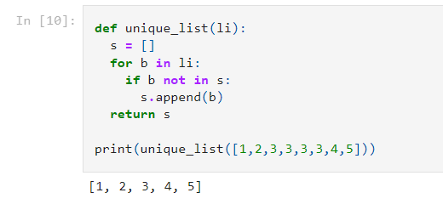

5) Write a function that accepts a string and calculate the number of upper-case letters and lower-case letters. Input String: 'The quick Brow Fox'

Expected Output:

No. of Upper-case characters: 3

No. of Lower-case Characters: 12

